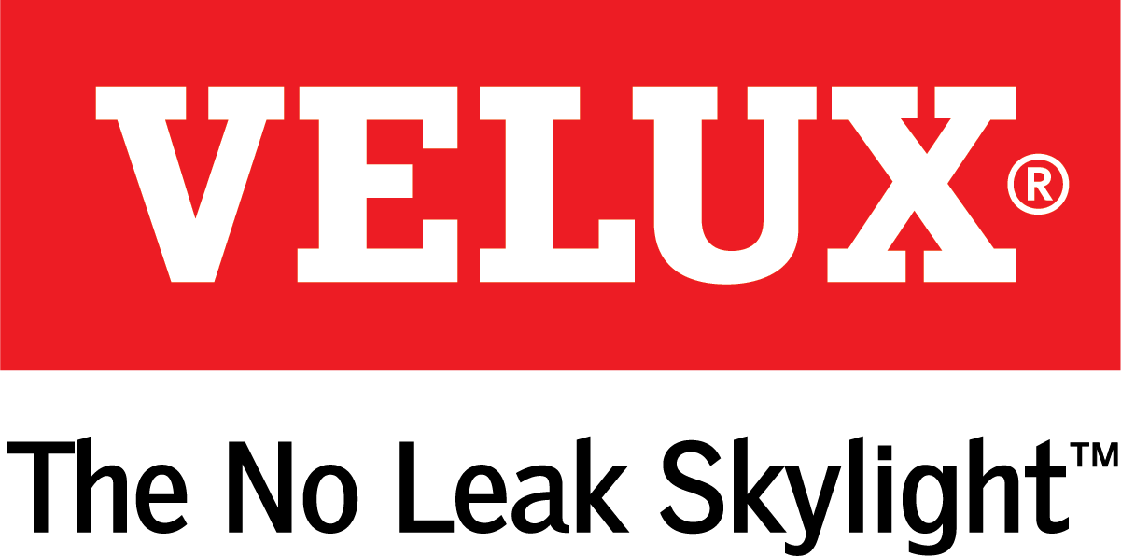
Media Contacts:
Kelsey Webb
704-790-1560
kwebb@wrayward.com

Dana Haydock
704-926-1301
dhaydock@wrayward.com

MAKE MODERN INDOOR LIVING HEALTHIER

WITH VELUX® ACTIVE SKYLIGHT AUTOMATION SYSTEM

Smart Home Technology System Compatible with Apple® HomeKit

LAS VEGAS, Feb. 19-21, 2019 – Modern indoor living has resulted in people spending, on average, 90 percent of their time indoors¹, often breathing stale and polluted indoor air. VELUX, the world leader in skylights and roof windows, offers VELUX ACTIVE with NETATMO to help combat the negative side effects of spending so many hours inside. The system is now available for purchase, and International Builders’ Show attendees can see how it works at the VELUX IBS booth C3307.
Indoor air is five times more polluted than outdoor air², and with people spending so much time inside, VELUX recognized the need to help homeowners use natural ventilation to air out their homes on a regular basis.
“VELUX ACTIVE is indicative of our commitment to healthy, energy efficient homes,” said Ross Vandermark, national product manager for VELUX America. “Every homeowner deserves clean air, and this automation system will help reduce the risk of health hazards, such as asthma, that are aggravated by poor indoor air quality. This system will automatically open the skylights for fresh air, so homeowners can worry less about the air they and their families are breathing.”
VELUX ACTIVE, which is compatible with Apple® HomeKit, allows homeowners to automate their skylights to more easily infuse natural light and fresh air into the home. The product supports the growing desire for smart home technology in the United States, with some projections showing the number of connected homes exceeding 35 million by 2021.
In an average home, the pollutant level is normally at a low level when people first enter the home or after effective ventilation. However, after an extended period of time, daily activities can raise the level of pollutants to unhealthy levels that can cause headaches, dizziness and sleepiness. Proper ventilation removes unwanted toxins, lowers CO2 levels and promotes an overall healthier lifestyle.
The system ensures a healthier indoor climate by automatically opening the skylights to air out the house two to three times daily. Here’s how it works: Smart sensor technology monitors CO2, humidity and temperature in the home, while the system also connects to online weather forecasts. It automatically opens the skylights if fresh air is needed inside.
It also automates blinds to help control indoor temperature. For example, the system will extend the blinds to block sunlight during the day in the warmer months or extend them at night during the winter for an added layer of insulation.
Homeowners can also use the VELUX ACTIVE smartphone app to control their skylights even if they are away from the house.
For more information on VELUX ACTIVE and the federal tax credit, visit whyskylights.com.

# # #

VELUX is the world leader in skylights and roof windows and is one of the strongest brands in the global building materials sector. VELUX America products are available nationwide through home centers, building material suppliers, lumberyards and independent door, window or roofing retailers. Consumers can locate local suppliers and installers and access information on skylight selection and the benefits of bringing more natural light and fresh air into the home by visiting www.veluxusa.com or www.whyskylights.com. VELUX skylights are made in America in Greenwood, South Carolina.

1) U.S. Environmental Protection Agency- Report to Congress on indoor air quality- Volume 2

2) U.S. Environmental Protection Agency- The total exposure assessment methodology (TEAM) study- Summary and analysis

